Chapter 3, Solution 11

Find V_{o} and the power absorbed by all the resistors in the circuit of Fig. 3.60.
6 Ω
+
_
60 V
–
+
24 V
12 Ω
12 Ω
V_{o}

Figure 3.60
For Prob. 3.11.

Solution
At the top node, KCL produces 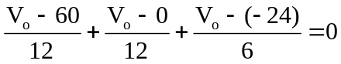

(1/3)V_{o} = 1 or V_{o} = 3 V.

P_{12Ω} = (3–60)²/1 = 293.9 W (this is for the 12 Ω resistor in series with the 60 V source)
P_{12Ω} = (V_{o})²/12 = 9/12 = 750 mW (this is for the 12 Ω resistor connecting V_{o} to ground)

P_{4Ω} = (3–(–24))²/6 = 121.5 W.

